HW Trigger using 6843 Radar

# Hardware Requirements

1. [DCA1000EVM](https://www.ti.com/tool/DCA1000EVM) with modifications
2. [MMWAVEICBOOST](https://www.ti.com/tool/MMWAVEICBOOST) with modifications
3. [IWR6843ISK](https://www.ti.com/tool/IWR6843ISK) (no modifications necessary)
4. Microcontroller to send HW trigger pulses

# Software Requirements

1. [TI mmWave SDK 3.5.0.4](https://www.ti.com/tool/MMWAVE-SDK)
2. [TI Uniflash](https://www.ti.com/tool/UNIFLASH)
3. [TI mmWave Studio 2.1.1.0](https://software-dl.ti.com/ra-processors/esd/MMWAVE-STUDIO/latest/index_FDS.html)
4. Josiah’s single or dual radar GUI
   1. Requires MATLAB

# Hardware Set Up

1. DCA1000EVM
   1. Remove R120
      1. Suggested [here](https://e2e.ti.com/support/sensors-group/sensors/f/sensors-forum/710632/awr1243-dca1000-and-1243-hardware-trigger-sts_no_lvds_data)
   2. Connect to the MMWAVEICBOOST with 60 pin connector as shown on page 16 [here](https://www.ti.com/lit/ug/swru546d/swru546d.pdf?ts=1620300878197)
   3. Connect to the PC over USB on the RADAR_FTDI/J1 connector and over Ethernet
   4. Connect 5V/3A power
2. MMWAVEICBOOST
   1. Remove R346 and short 348
      1. Suggested [here](https://e2e.ti.com/support/sensors-group/sensors/f/sensors-forum/972613/iwr6843isk-hardware-trigger) and [here](https://e2e.ti.com/support/sensors-group/sensors/f/sensors-forum/998616/iwr6843isk-custom-binary-for-cli-lvds-hw-trigger/3692785?tisearch=e2e-sitesearch&keymatch=%20user%3A448661#3692785)
      2. From [Josiah’s E2E post](https://e2e.ti.com/support/sensors-group/sensors/f/sensors-forum/998616/iwr6843isk-custom-binary-for-cli-lvds-hw-trigger/3692785?tisearch=e2e-sitesearch&keymatch=%20user%3A448661#3692785):
         1. Download xWR6843 EVM Schematic Drawing, Assembly Drawing, and Bill of Materials - SWRR164C.zip from [here](https://www.ti.com/tool/IWR6843ISK#design-files)
         2. On page 9 of PROC074B(001)_Sch.pdf (for rev B of the MMWAVEICBOOST), under "RNR FOR SYNC IN", 40PIN_SYNC_IN needs to be routed to RADAR_SYNC_IN
         3. From that diagram, DCA_SYNC_IN is shorted via R346 to RADAR_SYNC_IN
         4. Hence, remove R346 and place 0 ohm resistor over R348. Now 40PIN_SYNC_IN is routed to RADAR_SYNC_IN
   2. Switch settings
      1. From page 11 [here](https://www.ti.com/lit/ug/swru546d/swru546d.pdf?ts=1620300878197), use the switch settings below on S1 for DCA1000 Mode
   3. Connect to microcontroller (MCU)
      1. From [Josiah’s E2E post](https://e2e.ti.com/support/sensors-group/sensors/f/sensors-forum/998616/iwr6843isk-custom-binary-for-cli-lvds-hw-trigger/3692785?tisearch=e2e-sitesearch&keymatch=%20user%3A448661#3692785):
         1. On page 8 of PROC074B(001)_Sch.pdf and page 19 of [here](https://www.ti.com/lit/ug/swru546d/swru546d.pdf?ts=1620300878197), 40PIN_SYNC_IN is pin 9 of J5 **(IMPORTANT)**
            1. See picture [here](https://e2e.ti.com/support/sensors-group/sensors/f/sensors-forum/972613/iwr6843isk-hardware-trigger) for pin 9 of J5 input
         2. Ground is pin 4 of J5 or pin 2 of J6
   4. Connect to the PC over USB on XDS110_USB/J1 and attach IWR6843 as shown on page 16 [here](https://www.ti.com/lit/ug/swru546d/swru546d.pdf?ts=1620300878197)
   5. Connect 5V/3A power

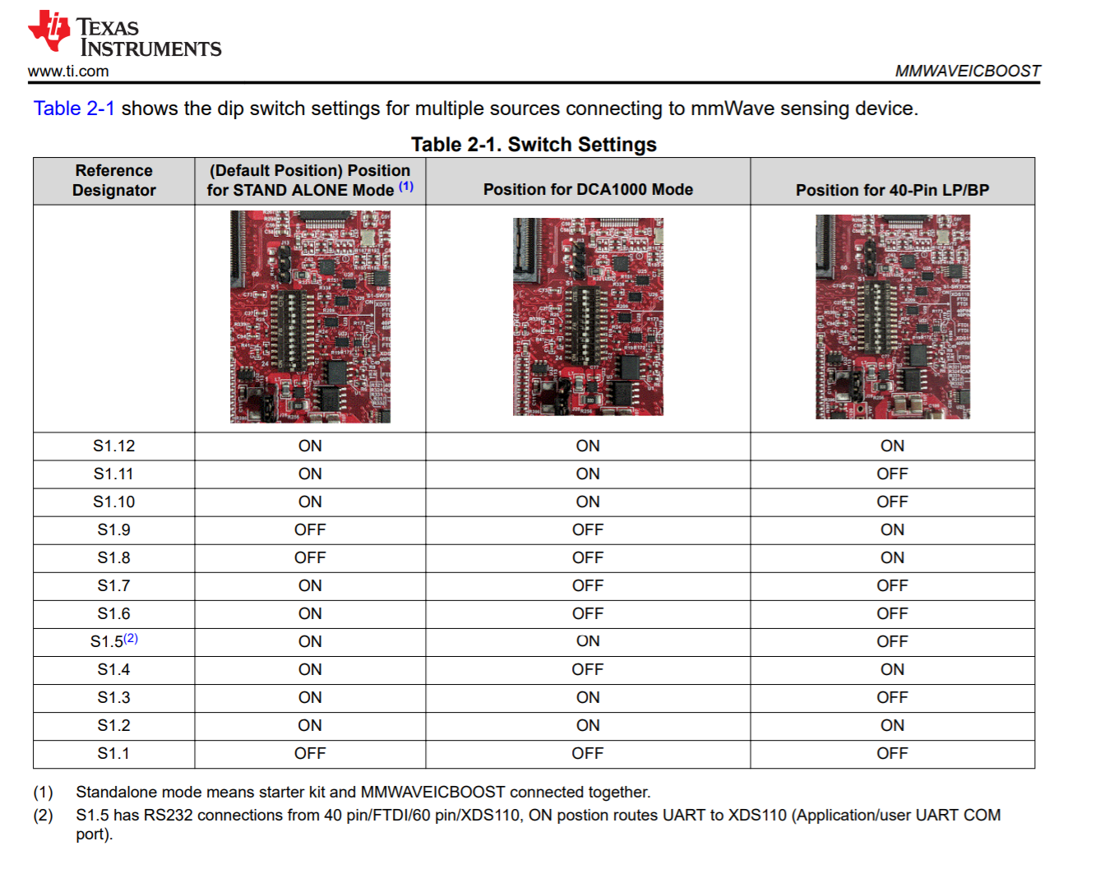

1. IWR6843ISK
   1. Switch settings
      1. From step 1 [here](https://dev.ti.com/tirex/explore/content/mmwave_industrial_toolbox_4_7_0/labs/common/docs/hardware_setup/hw_setup_mmwaveicboost_mode_flashing.html) or page 45 [here](https://www.ti.com/lit/ug/swru546d/swru546d.pdf?ts=1620300878197), use the switch settings below on S1

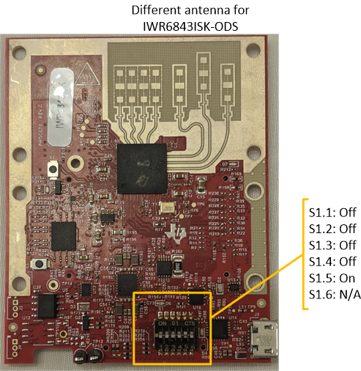

* + 1. Connect to MMWAVEICBOOST as shown on page 16 [here](https://www.ti.com/lit/ug/swru546d/swru546d.pdf?ts=1620300878197)

# Software Set Up

1. Flash the SDK demo to the MMWAVEICBOOST (See [SDK 3.5.0.4 User Guide](http://software-dl.ti.com/ra-processors/esd/MMWAVE-SDK/latest/exports/mmwave_sdk_user_guide.pdf) section 4.2)
   1. Set the device to Flash Programming Mode by bridging SOP0 and SOP2 as shown in step 5 [here](https://dev.ti.com/tirex/explore/content/mmwave_industrial_toolbox_4_7_0/labs/common/docs/hardware_setup/hw_setup_mmwaveicboost_mode_flashing.html)

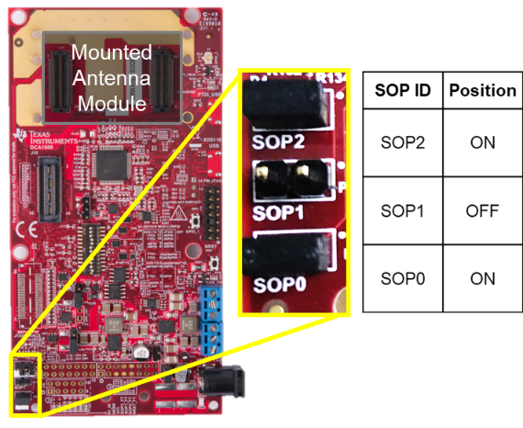

* 1. Power cycle the MMWAVEICBOOST
  2. Once the device is properly connected to the PC, download the demo firmware using Unifash
     1. Typically under the path: “C:\ti\mmwave_sdk_03_05_00_04\packages\ti\demo\xwr68xx\mmw”
  3. Once the download is complete, set the device to Functional Mode by bridging only SOP0 and remove the bridge on SOP2
  4. Power cycle the MMWAVEICBOOST

1. Setup the DCA1000EVM on the proper IP address (See the [DCA1000VEM Quick Start Guide](https://software-dl.ti.com/ra-processors/esd/MMWAVE-STUDIO/latest/exports/DCA1000_Quick_Start_Guide.pdf))
   1. Once the device is properly connected to the PC, open the start menu and search “View Network Connections”

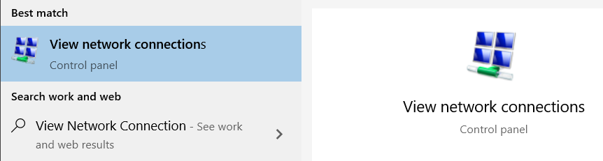

* 1. Inside the “Network Connections” of Control Panel, right click on the Ethernet port of choice and select “Properties”
  2. “Local Area Connection Properties” window will open. Right click on “Internet Protocol Version 4 (TCP/IPv4)”.
  3. “Internet Protocol Version 4 (TCP/IPc4)” window will open. Set the IP address field to 192.168.33.30, or the desired IP address if different
     1. See our other documentation on changing the IP address of the DCA1000EVM using the DCA1000 CLI Utility (necessary for a dual radar setup)
  4. The Subnet mask field can remain the default 255.255.255.0
  5. Press “OK” on all the windows and you can close “Network Connections”

1. Open the Josiah’s single/dual radar GUI
   * 1. “dual_radar_gui.mlapp.”
   1. App Designer window will open to the app of your choice in the previous step
   2. Press “Run” at the top of the page
   3. The app will open and all the indicators will be red
      1. Assuming you have installed mmWave Studio 2.1.1.0 to the typical location, it will open normally. Otherwise, it will ask you to find the installation location of mmWave Studio 2.1.1.0
   4. Change the Start Freq (GHz) field to 60 GHz
   5. Press “Connect Radar 1”
   6. A window will appear asking to select a serial COM port. Select the COM port corresponding to the entry in device manager labeled “XDS110 Class Application/User UART”.
   7. Press “Prepare DCA 1”
   8. Enter the desired chirp parameters
   9. Press “Configure Radar”
   10. Press “Start” to start the capture
       1. The DCA1000EVM will start waiting for data over LVDS
       2. The MMWAVEICBOOST and IWR6843ISK will wait for HW trigger from MCU
          1. If everything is working properly at this point, the D7 LED on the IWR6843ISK and the DS2 LED on the MMWAVEICBOOST will turn on
   11. Start the MCU sending pulses
       1. If everything is working properly the DATA_TRAIN_PRG LED on the DCA1000EVM will be flashing while the radar is triggered
   12. Press “Stop” to stop the radar once you are done